Canvas Course close out
Best practices for Canvas course close out include creating an ‘exported’ course copy on your computer. To export a Canvas Course package:

Open Settings
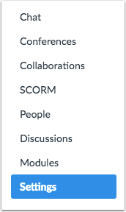

On the right side of the screen select: Export Course
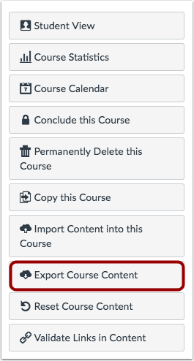

Select Export Type
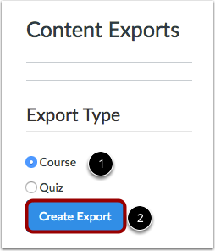
In the Export Type heading, click the Course radio button [1]. Click the Create Export button [2].

Note: If you have previously exported the course, Canvas will display prior exports under the Content Exports heading.

View Export Process
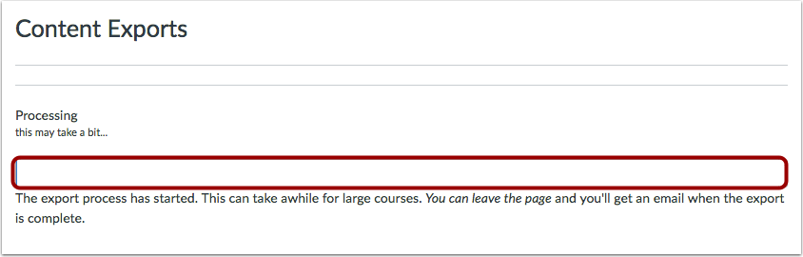
View the progress bar. Exporting a course in Canvas may take a few minutes, depending on its size. You will receive an email when the export is complete.

Download New Export
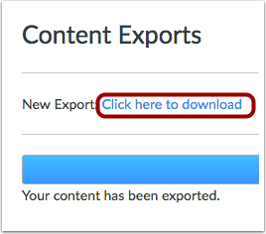
When your download is ready, click the Click here to download link.

The file download is a zipped .imscc file that can only be opened when loaded back into Canvas. Drag and drop the file into a course file on your computer to be used only in the unlikely event your Canvas course content is deleted. Caution: if you test this uploading the course files, all files in your course will be duplicated.

To import content from a zipped course file:

Open Settings

On the right side of the screen select:
Click the Import Content into this Course button.

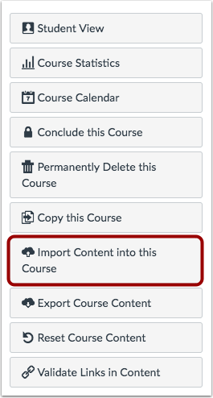

Select Content Type
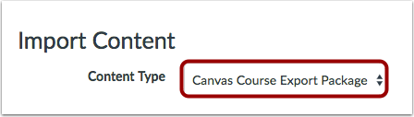
In the Content Type drop-down menu, choose the Canvas Course Export Package option.

Choose File
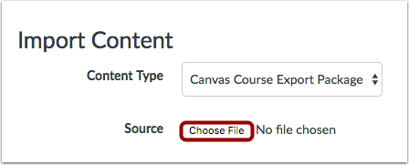
Click the Choose File button.

Open File
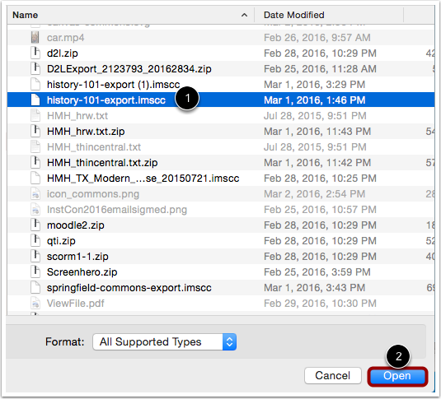
Choose the .imscc file you want to import [1]. Click the Open button [2].

Select Migration Content
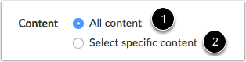
To import all content from the course, select the All Content radio button [1].

If you want to select specific content, click the Select specific content radio button [2].

Note: If you select the specific content option, you are required to select the content you want to import after you review the remaining page options. After you start importing the content, the import selection cannot be canceled.

Adjust Events and Due Dates
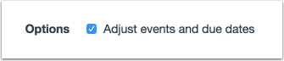
If you want to adjust the due dates associated with the course events and assignments, click the Adjust events and due dates checkbox.

Import Course
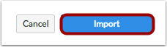
Click the Import button.

View Current Jobs
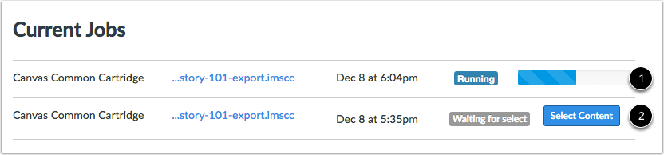
The Current Jobs section displays the status of your import. Running reports display a menu bar with the time remaining to complete the import [1].

If you chose to select specific content in your course, the current job will show as ‘Waiting for Select’ [2], which means you must select the content you want to import.

The import may also display other status indicators as part of the import process. Learn more about course import statuses.

View the content from any completed imports by accessing any link in Course Navigation.

